**Homework 8 (Prolog)**

**Programming Principles and Implementation**

**Yevgeniy Shatrovskiy**

**PROLOG**

1. Let us consider the following set of facts that describe the mother predicate.

mother(linda, paul).

mother(cathy, andrew).

mother(cathy, laura)

extra added => mother(cathy, laura).

* Define a predicate female(X) which holds iff X is a female

female(sandy).

female(laura).

* Define a predicate sister(X,Y) which holds iff X and Y are sisters

sister(X,Y) :- mother(Z,X), mother(Z,Y), female(X), female(Y), X \= Y.

* Implement female and sister in PROLOG
* Provide screenshots

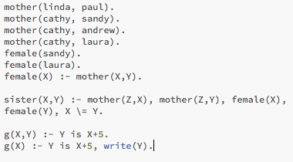

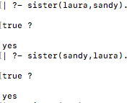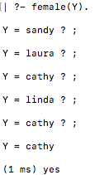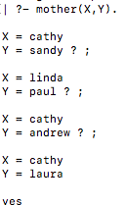

Implement the function g such that g(x) = x+5.

g(X,Y) = Y is X+5.

or

g(X) = Y is X+5, write(Y).

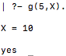../Desktop/Screen%20Shot%202017-12-20%20at%2010.42.50%20AM.png